Sudden Impact
A western RPG

Process Oriented Programming (1DT049), project proposal for group 1, version 1, 04/25/12.

Participants:
Olof Björklund | 880304-7136
Marcus Utter | 890830-1974
Mark Tibblin | 870519-7898
Luis Armando Mauricio | 840911-0791

    - Brainstorm

This project is about making a simple multiplayer game using concurrent Erlang programing. Different ideas came to mind, some of these where:

- A duel-game / user-interaction-based-game, working concurrently over peer-to-peer network.
- A MUD (Multi User Dungeon) game working concurrently over network.

Other idéas where:
- A simple torrent client.
- A simple game-server

A M.U.D could have been a possible project, but after some discussion we agreed that it would be more interesting to create something with a bit more graphics than a plain text-based MUD.

The first thought was to make a game for peer-to-peer network. After some discussion with Karl Marklund we agreed to first make an implementation working over a virtual environment to later be ported as a peer-to-peer project, if there is time.

For this we received some tips for a previous lab in this course which Karl thought might have some relevance for the creation of such a project, namely the “Gnutella” lab:
http://www.it.uu.se/edu/course/homepage/p2p/st09/labs/gnutella

Making a game working concurrently would mean that two players should be able to take an action more or less at the same time and concurrently receive results from the program, based on both their own and the opponents actions.

For this scheme a simple duel-game would be the optimal starting point since this could easily be extended to perhaps a MUD or some other type of game. Focus should lie on making the games network-properties work correctly than actual game-experience.

Comparing these different project suggestions we agreed that making a torrent client would be to complicated since none of us have a full understanding of torrent-mechanics, and such knowledge would be critical in the process of making a torrent-client. The concurrency in such a project would lie in making many trackers work as one, or at one time. How this would be done in Erlang we decided not to look in to.

Our brainstorm-section of this project was short when we more or less agreed from the start what would be a fun project to do. Mostly, our brainstorm was more specific. Focusing on such questions as “What would be to complex to do concerning Eralng network programing?” or “What type of network should be used?” and “Which language would be the most effective/fun/educational”.

    - Project selection
We decided to start out with a virtual-environment version of a duel-game and later, if there is enough time, port it to work on its own as peer-to-peer. Out thought is that the game will act much like any isometric RPG with players moving about freely and bumping into each other to start a duel. This seemed like the best choice out of the others cause we all thought it would be the most fun and educational to do.

Making a network-based concurrent-game would be especially interesting because we get to touch the most important parts of Erlang programing and see some of its potential in network communication. This will in turn teach us some Erlang for greater good, and more specifically we will learn a lot more about concurrency and network programing within. What we have yet to discover is if a simple server-based service implementation would be simpler than a peer-to-peer implementation.

Furthermore, we hope to learn more about how to plan system architecture and maybe even combine two different programing-languages in the same project.

One challenge of this project will be to write tests for network-based communication. Another obstacle will be to try and combine two different languages; Erlang for the network/game-logic part and Java for the GUI.

For the time-planing of the project the SCRUM method will be used. This because everyone in the group finds the method both efficient and good working.

    - System architecture
Everybody in the group agrees that Erlang would be the most interesting selection for main-language.

At this stage we imagine peer-to-peer would be the simplest way of creating concurrent network-based communication. Testing the system will be done using gen_fsm (finite state machines) to simulate a certain scenario, with an expected outcome, which can be tested compared to expected results. For the graphical interface we are looking into different solutions but a simple Java-GUI seems like a good candidate. It is possible, at this stage, that some Java will be used for the actual game-logic, depending on how well Java can communicate with Erlang. But the goal here is to use as much Erlang programing as possible.

A mind-map version of the System architecture can be seen in figure 1 below.
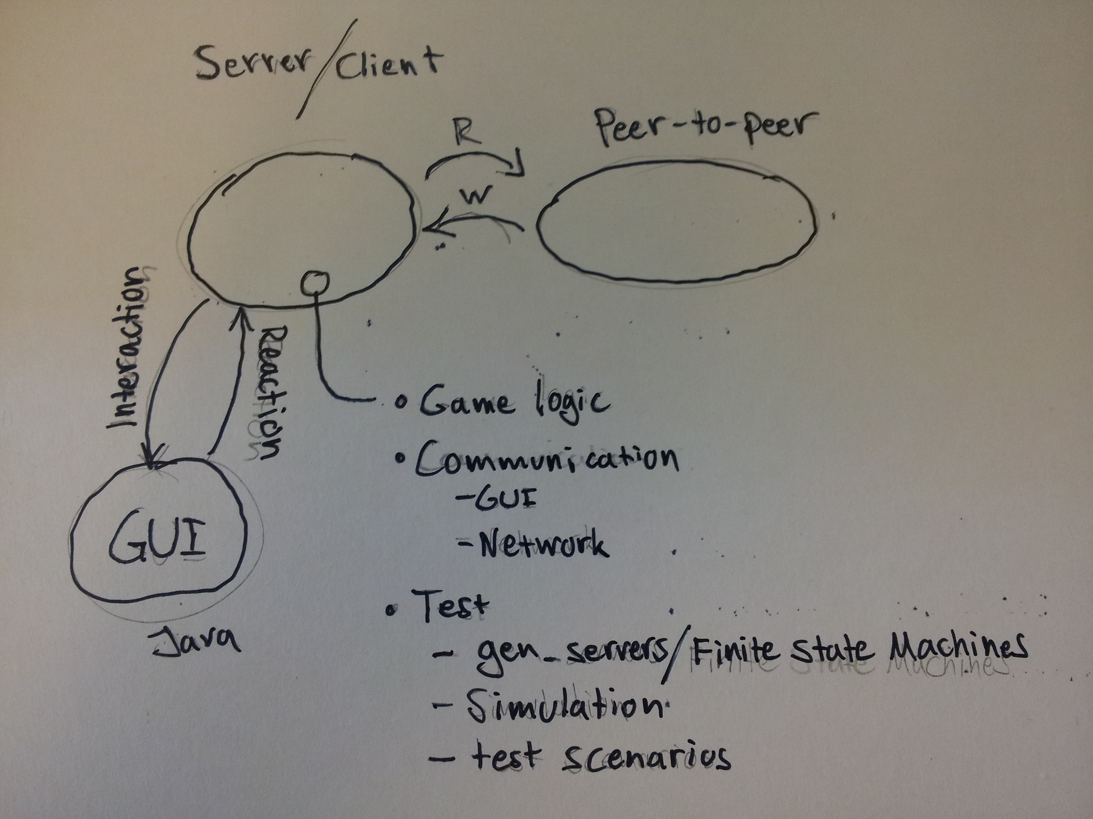
Figure 1, basic system architecture


Figure 2, peer-to-peer network
(04/24/12, http://en.wikipedia.org/wiki/Peer-to-peer)

The idea for peer-to-peer in our case will be that whenever a player is the first to start looking for an opponent that player will become the server. When another player joins the search he/she will connect to the hosting server as a client. This models as figure 2.

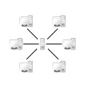
Figure 3, server-based network
(04/24/12, http://en.wikipedia.org/wiki/Peer-to-peer)

If we find that making a peer-to-peer implementation will be to difficult we will port the solution to a simple server-based network as seen in figure 3.

    - Concurrency models and programming languages
We chose to do the most-part of our programing in Erlang. This because we find Erlang to be an interesting language we all wish to learn more about. Also Erlang is a particular good choice for programing concurrently without sharing memory, hence the actor model. Since we're planing to use Erlang for the concurrent programing, it naturally follows that the actor model will be used because that's intended in Erlang, and we want to prohibit memory shared resources.

For the GUI we believe that Java will be the best way to go. This because designing a simple graphical interface in Java is quite simple. The only problem here will be to get Java communicating with the Erlang core.

    - Development tools
Table 1
IDE | Language | Distribution | Build/execution | Documentation | Testing
Sublime/eclipse/emacs | Erlang | GIT | Rebar / Makefile | Edoc | Eunit
Sublime/eclipse/emacs | Java | Mercurial / GIT | IDE | JavaDoc | Junit

We will use an IDE for code-development. This because it simplifies overview and generally makes programing less of a hassle and lowers the risk of faulty-code. IDE's to be used are Eclipse and possibly Emacs or Sublime.

GIT will be used for code distribution amongst the group members. The repository is added under user Drotten with git-link: git@github.com:Drotten/projekt-pop

To build/make we will use Rebar for Erlang. This because we want to learn Rebar.

For documentation we will use Edoc for Erlang and Javadoc for Java. This because they exist and work. We plan to use these tools to get a nice overview of the code / code-parameters to simplify basic code-understanding.

To see the different development tools of choice, see table 1.

PROJEKTANTECKNINGAR

05/04/12

The first tutoring-meeting took place. Discussions concerning programing architecture and map-layout. Two options are available concerning the player/bot representation on the map. Either “solo-object” representation where a player would ask every other player for their coordinates before moving to a certain position, to identify possible collision or “map-awareness” where the map itself keeps track of each players position and a players communicate with a “hash-table” or “global-position-function” to verify move possibility.

To compare and decide between the two methods we made a pros/cons list:

Method | Pros | Cons
“Solo object” | - Independent  - “true” concurrency  - crash-safe | - resource-consuming for bigger scenarios  - test-difficulties  - overview-difficulties
“Map-awareness” | - One variable access  - easy access and evaluation  - test-friendly  - easier to make | - “global dependency”  - less concurrent  -

A discussion will be held concerning the choice of method.

05/08/12

Vi ska fråga Karl om följande:

Makefilen kan inte köra make start för vårt program.

Hur dödar vi processer?

Visa felet som uppstår då vi försöker gå 5 ggr åt samma håll med botarna

After some discussion, we decided to use the “Map-awareness” method.

The Erlang game logic works somewhat like it should now. Some test-cases have been made but we find it difficult to test for messages being sent between processes. Help from Karl ?

JAVA:

A problem that has occurred is that Javac classpath does not work as expected. Netbeans solved this problem, so for the Erlang – Java communication Netbeans will be used instead of eclipse/sublime.

